**A FULL STACK DEVELOPMENT CAPSTONE PROJECT**

FoodBox

*Source Link: https://github.com/UdayBoppapuram/Foodbox*

* **Version History:**

|  |  |  |
| --- | --- | --- |
| 1. | **Author Name** | Boppapuram Uday |
| 2. | **Purpose** | Source of Application. |
| 3. | **Date** | 25 April 2023. |
| 4. | **Version** | 1.0 |

Contents.

* 1. Project Outputs
  2. Source Link……………..
  3. Screenshots…….
  4. Admin view…..
  5. Customer view…
  6. Payment Gateway…

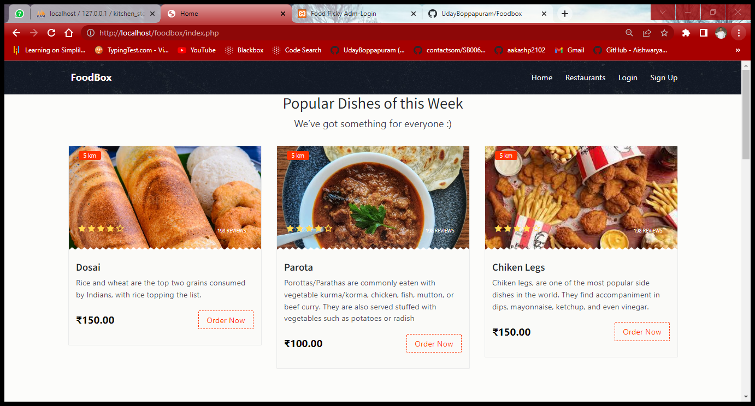***1.Project Outputs.***



A. Home Page.



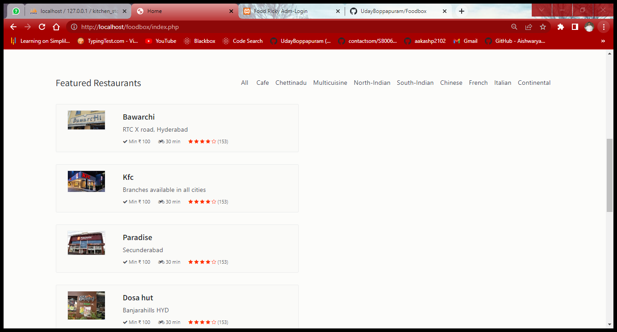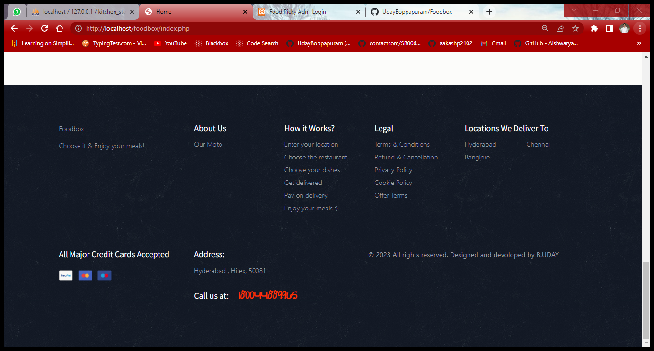





B. Login and Registration Page.

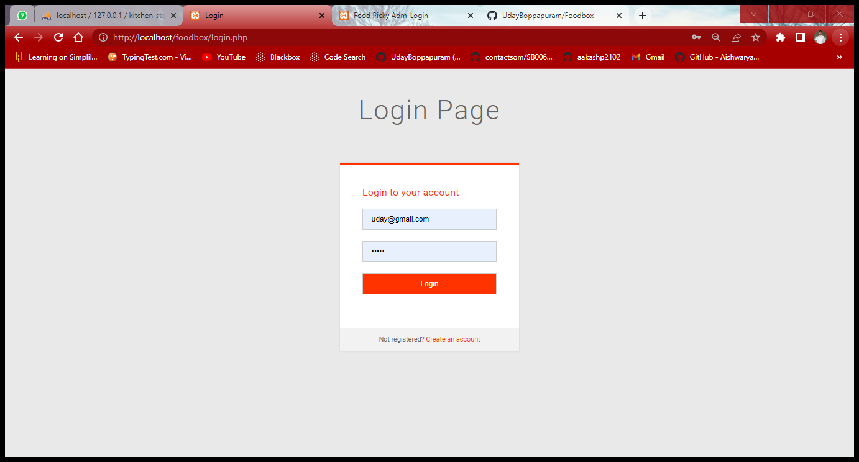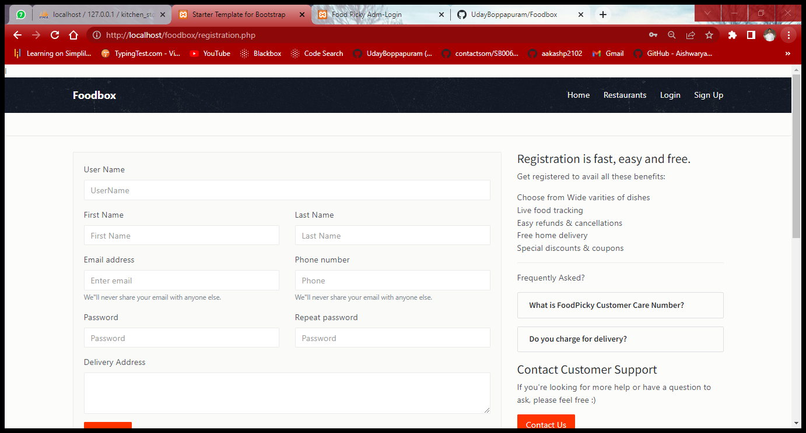





C. Admin Login Page.

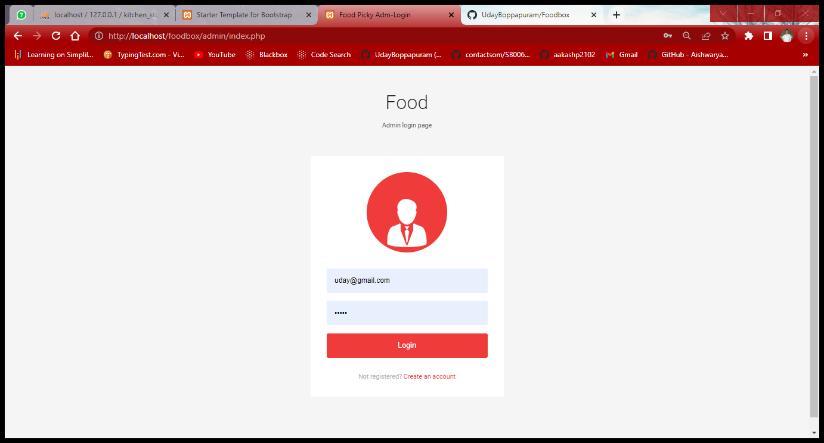



D. Manage Users , Products , Purchases.

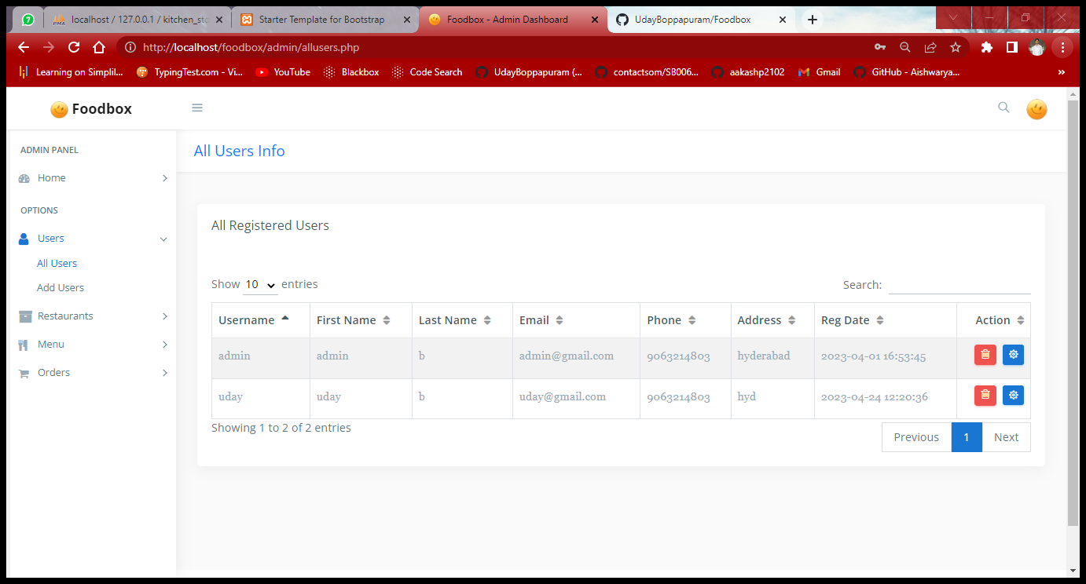

Manage Menu:

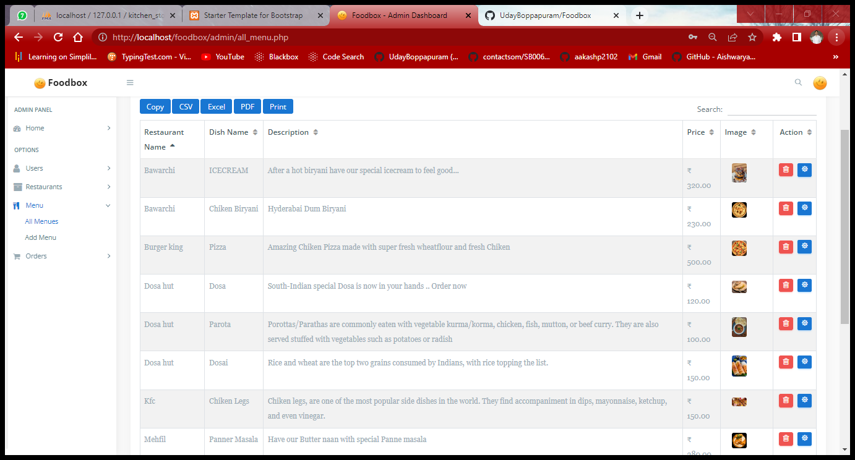

Add Product:

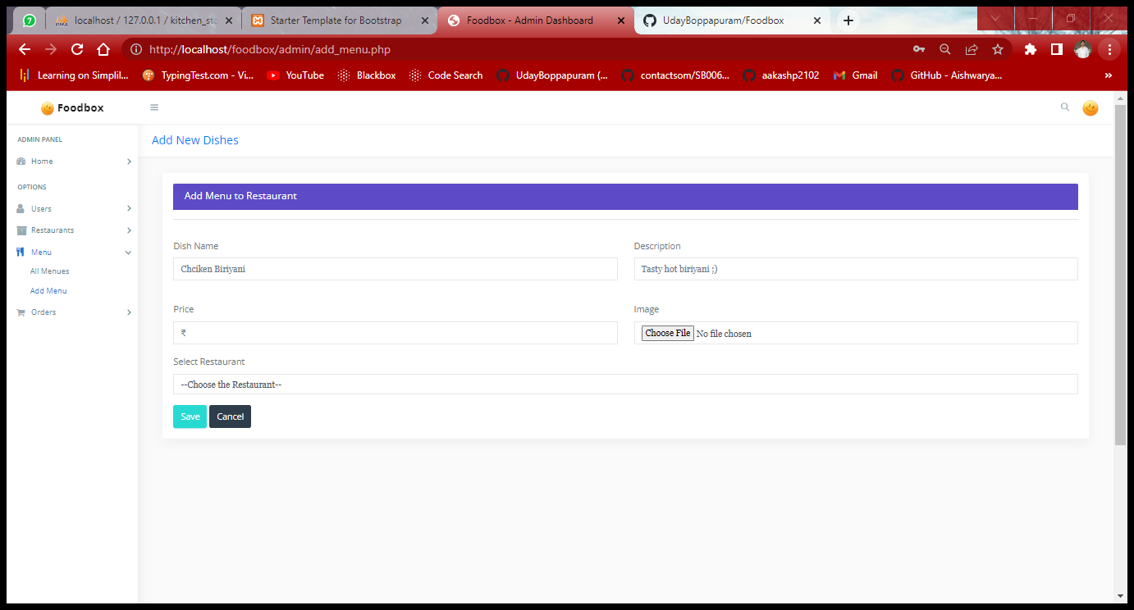

Update Restaurant:

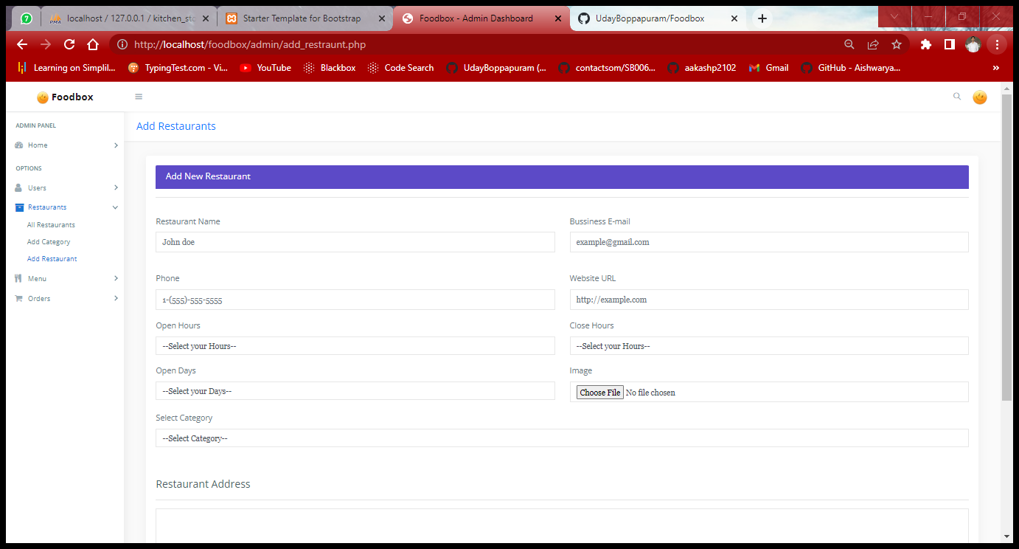

All Restaurats:

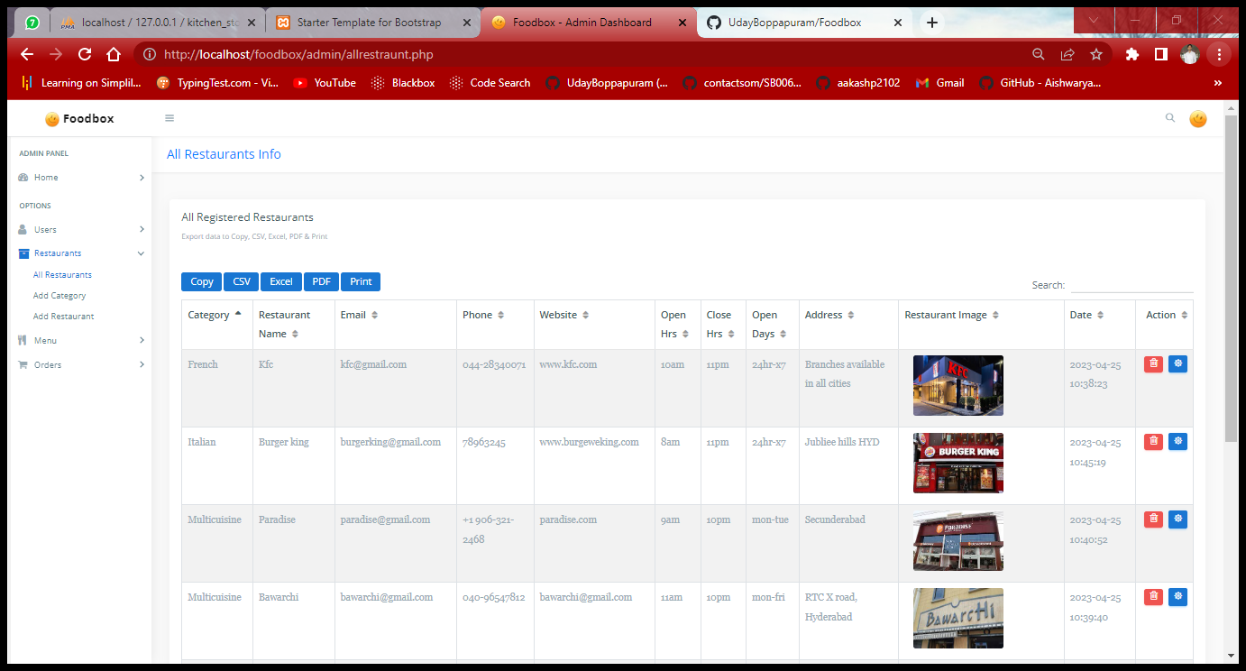

Product deleted successfully…..

Manage Purchases:

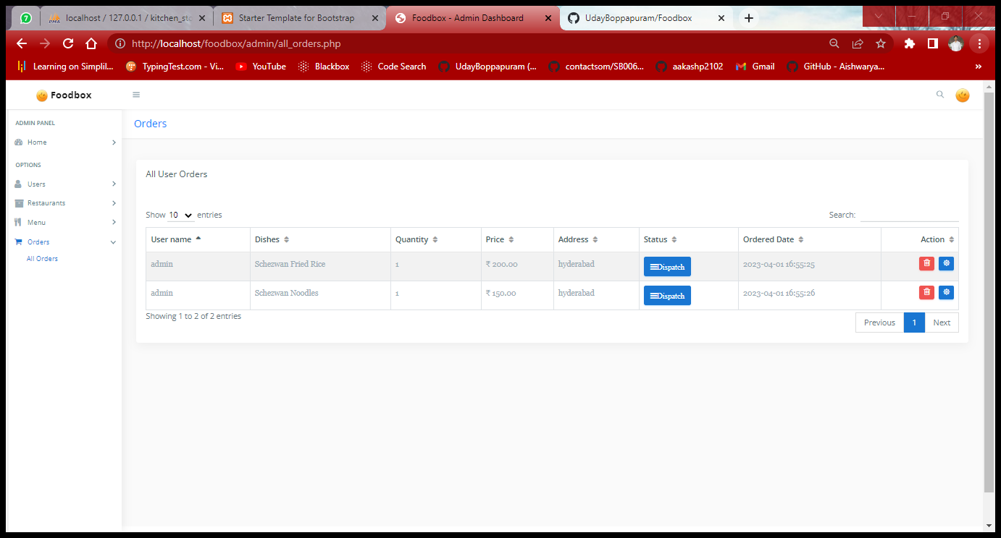

Admin Dashboard:

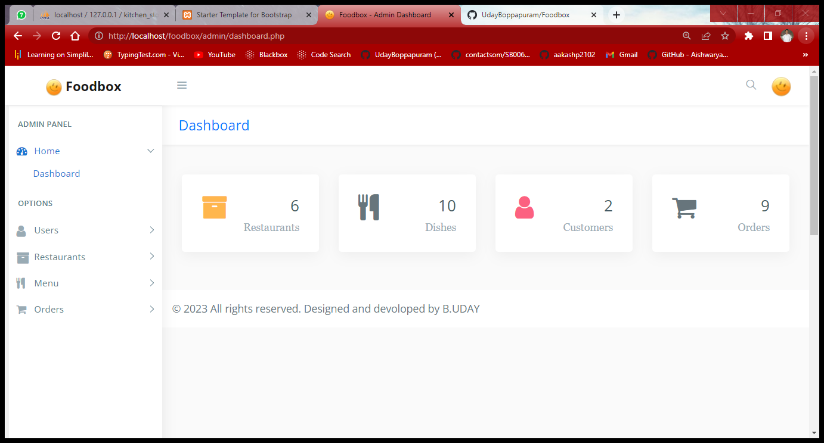



G. Add Cart / View Cart from user side.

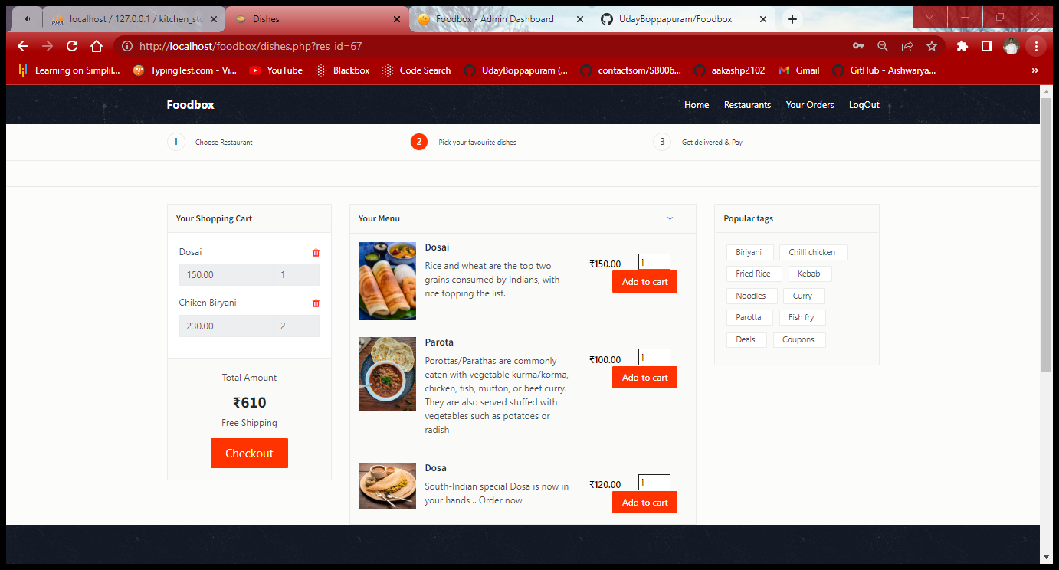



Payment Gateway Page.

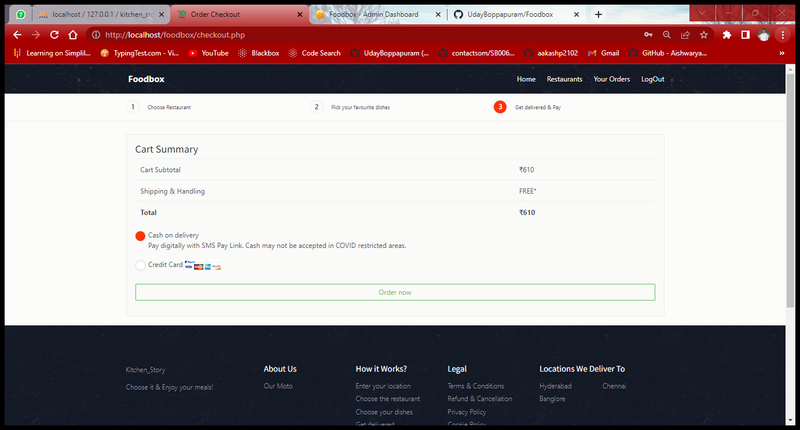

**Thank You**

16